# 1. OSHA PIT REGULATORY REQUIREMENTS

Forklift powered industrial truck safety requirements are covered under OSHA Standard Number ____________.

According to OSHA, a forklift powered industrial certification must include:

___________________________________________________________________________________

___________________________________________________________________________________

___________________________________________________________________________________

___________________________________________________________________________________

Operators must be evaluated every __________ years.

Forklift PIT refresher safety training is needed if: (Place check mark next to all correct answers)  
 a. Operator is operating PIT unsafely  
 b. Accident or near-miss incident occurs  
 c. Operator is assigned different type of PIT  
 d. Changes in the workspace  
 e. Operator fails an evaluation

Why does OSHA require specific forklift safety training?  
a. ___________________________________________________________________________________  
b. ___________________________________________________________________________________  
c. ___________________________________________________________________________________  
d. ___________________________________________________________________________________

# 2. FORKLIFT PIT STATISTICS

On average there is ____________ forklift PIT fatality every ____ days.

_____________ of all forklift PIT accidents are due to rollovers.

_____________ of all forklift PIT related deaths are pedestrians.

According to OSHA, 70% of all forklift PIT related accidents could have been _____________.

How can we prevent forklift PIT related accidents? (Place a check mark next to the correct answers)

a. Regularly assess the workplace to identify and control potential forklift PIT hazards.  
 b. Implement a forklift PIT training program as required by OSHA standards.  
 c. Terminate employees on the spot for operating a PIT forklift unsafely.

# 3. PIT CLASSIFICATIONS

Write in the letter of class that corresponds with the correct type of forklift. The first one has been completed.

|  |  |  |  |  |
| --- | --- | --- | --- | --- |
| a. | Class I |  |  | Internal Combustion Engine Trucks (Pneumatic Tires) |
| b. | Class II |  |  | Rough Terrain Forklift Trucks |
| c. | Class III |  |  | Electric and Internal Combustion Engine Tractors |
| d. | Class IV |  |  | Internal Combustion Engine Trucks (Cushion Tires) |
| e. | Class V |  | a. | Electric Motor Rider Trucks (Cushion or Pneumatic) |
| f. | Class VI |  |  | Electric Motor Hand Trucks or Hand/Rider Trucks |
| g. | Class VII |  |  | Electric Motor Narrow Aisle Trucks |

Which of the following equipment is covered on the OSHA 1910.178 PIT standard? (Place check mark next to all correct answers)

a. Scissor Lift  
 b. Front loader with over bucket forks  
 c. Manual pallet jack, non-motorized  
 d. Walk behind motorized pallet jack  
 e. Narrow aisle lift, order picker

What considerations should be given toward the type of class PIT that will be used in a work environment?

a. ___________________________________________________________________________________  
b. ___________________________________________________________________________________  
c. ___________________________________________________________________________________

# 4. FORKLIFT PIT INSPECTIONS

When forklift PITs are used on a round-the-clock basis, they shall be examined after each __________________ .

The __________ is a common area where damage such as surface cracks can occur.

_____________ all corrective action items and maintenance work on PITs.

Name four common items to look for when conducting your visual PIT inspection.

___________________________________________________________________________________

___________________________________________________________________________________

___________________________________________________________________________________

___________________________________________________________________________________

# 5. REFUELING AND RECHARGING

Always ____________ engine before refueling or recharging.

Always wear ____________________________ before refueling your Liquid Propane Gas (LPG) forklift. Contact with liquid propane can cause freeze burn.

When you have finished refueling your LPG, you should check for _________ before restarting the engine.

Refueling and charging areas should have a ________________________ in the event of a fire.

Battery charging areas should have adequate ventilation and an eyewash station with at least _______ minutes of continuous flow.

When servicing a PIT battery, one should always pour ______________ into water, never _________ into acid.

Never allow _____________ or sparks around refueling or recharging areas.

True or False. You should only conduct refueling or recharging if you have been trained? ________________

# 6. SAFE OPERATING PRACTICES

When entering or exiting a forklift you should:

a. Use a _______________________________ of contact.  
b. Never ____________________ .  
c. Keep the steps and floor of the forklift ________ and ________ .

If your sit-down forklift is tipping over:

a. Never ________________ out of the forklift.  
b. Plant your feet on the forklift’s ________________ .  
c. Grasp the steering ________________ .  
d. Lean ________________ and ________________ from the impact.  
e. Always wear your ________________________ !

Which of the following are forklift specific operating challenges? (Place check mark next to all correct answers)

a. Variable weight  
 b. Lack of suspension  
 c. Rear-wheel steering  
 d. Long stopping distance

Name four safe operating practices when driving a forklift with a load:

___________________________________________________________________________________

___________________________________________________________________________________

___________________________________________________________________________________

___________________________________________________________________________________

Which safe operating practices listed below should be followed when operating with a restricted view  
(Place check mark next to all correct answers)

a. Be aware of your surroundings  
 b. Alert others  
 c. Whenever safe and possible, drive your forklift in reverse with large loads  
 d. Block off area to pedestrians  
 e. Make use of a spotter

Name four common mistakes that forklift operators should never do:

___________________________________________________________________________________

___________________________________________________________________________________

___________________________________________________________________________________

___________________________________________________________________________________

What safety buffer distance is recommended:

a. Maintain a ___________ safety buffer when traveling ___________ a load.  
b. Maintain a ___________ safety buffer when traveling ___________ a load.

Write in the correct direction of travel when operating a forklift on an incline.

Inclines:

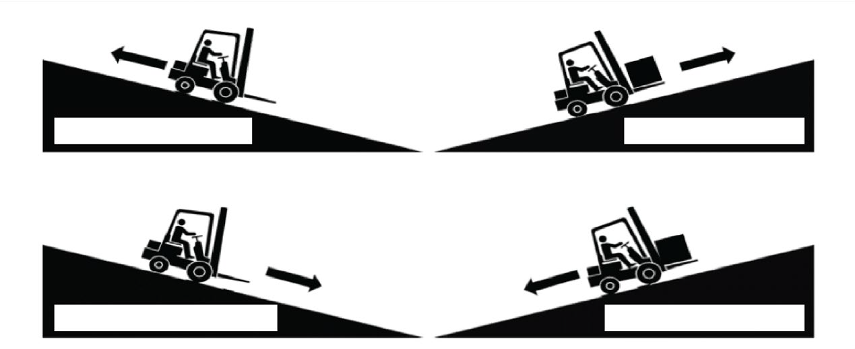

OSHA considers a forklift unattended if it’s not in _____________ of the operator or if the operator is ________ feet or more away from it.

# 7. LOADING AND UNLOADING PRACTICES

Which of the following safe loading practices listed below should be followed? (Place check mark next to all correct answers)  
 a. Examine the material.  
 b. Arrange the load for stability.  
 c. Place the heaviest items against the back.  
 d. St the forks as wide as safely possible.  
 e. Never use a counterweight to balance out a load.

When unloading, move your forklift into ________________ before raising the ________________ .

Why should we never allow anyone to walk, stand or pass under a raised load?

___________________________________________________________________________________

___________________________________________________________________________________

**8. READING CAPACITY PLATES**

The capacity plate can be often found on the ________________________ of the forklift.

What do the capacity plates tell the operator?

___________________________________________________________________________________

___________________________________________________________________________________

If the capacity plate is missing or illegible, immediately pull the vehicle from _________________ .

Using the example below, if the mast is extended upwards at a max height of 189 inches, and the load center is 30 inches from the mast. The maximum capacity is _________________ .

# 9. THE STABILITY TRIANGLE

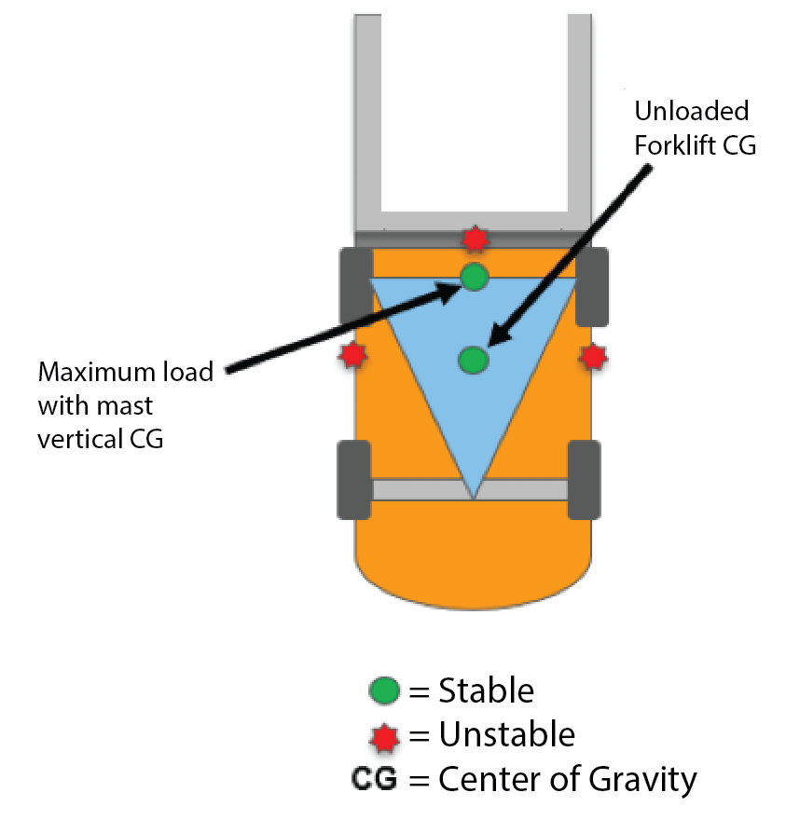A forklift has _____________ points of stability which includes the two front tires and the point on the rear axle.

The ___________ ___________ ___________ must remain inside the stability triangle otherwise the forklift will turnover.

Never drive your forklift with the ______________ extended.

Always travel with the _________ as _________ as possible.

Do not _____________ _____________ debris or objects.

Using the figure below please answer the following questions:

a. An unloaded forklift with forks maintained low will keep the center of gravity at the _________ of the stability triangle.  
b. A forklift with a maximum load and the mast vertical will move the center of gravity to the _________ of the stability triangle.

# 10. LOAD SAFETY PRACTICES

What factors will cause the forklift to tip over: (Place check mark next to all correct answers)

a. Driving too fast around corners  
 b. Turning with an excessive high raised load  
 c. Carrying loads that exceed the forklift rated capacity  
 d. Carrying loads with the mast tilted forward

As an operator you should always check: (Place check mark next to all correct answers)

a. Shipping documentation.  
 b. Item or product.  
 c. Weights and measures standards  
 d. Weight of attachments and accessories.  
 e. Products place of origin

**11. CALCULATING MAXIMUM LOAD CAPACITY**

The distance from the mast to a load’s center of gravity is called the _______________________ .

As the actual load center increases, your maximum load capacity ____ . You should always round maximum load capacity figures ___________ .

On the sample problem, the distance from the axle to the mast on the forklift is __________ inches.

**12. PEDESTRIAN SAFETY PRACTICES**

Why is it important for forklift operators and pedestrians to use eye contact before proceeding?

___________________________________________________________________________________

___________________________________________________________________________________

Always give pedestrians the ________________ _____________ _____________ .

Which of the following are pedestrian safety practices: (Place check mark next to all correct answers)

a. Operators must know where pedestrian traffic areas are located.  
 b. Pedestrians must receive safety training.  
 c. Separate pedestrians from forklift traffic e.g. by using painted yellow lines, yellow floor tape,   
 barrier systems.  
 d. Use convex mirrors at blind intersections.

What should a forklift operator do if his/her back up alarm is not working on their forklift?

___________________________________________________________________________________

___________________________________________________________________________________

Before going through a blind intersection, the forklift operator must __________ and use the __________   
before proceeding.

Areas with high forklift traffic should be _________________ to pedestrians.

**13. FORKLIFT ATTACHMENTS AND ACCESSORIES**

All attachments must be approved by the:

a. Manager  
 b. Forklift PIT manufacturer  
 c. Co-worker  
 d. Department of Transportation

Which of the following are safe practices for using forklift attachments: (Please check mark next to all  
correct answers)

a. Know the weight limits of attachment.  
 b. Ensure capacity plates are posted on the attachment.  
 c. Never attach slings, cables, or chains to the forks.  
 d. Read the attachment owners manual.

What three items must a work platform be equipped with?

a. ___________________________________________________________________________________  
b. ___________________________________________________________________________________  
c. ___________________________________________________________________________________

When raising someone on a work platform, the operator must remain at the _____________________  
at all times.

Always __________________ the work platform before _____________ the forklift.

**14. FORKLIFT OPERATOR EVALUATION**

The evaluation will help us identify ___________________ and ___________________.

True or False. Anybody in the company conduct the Forklift operator evaluation?

The evaluation will help us determine if ________________________ ____________________ is needed.

[icwgroup.com](https://www.icwgroup.com/)

ICW Group is the marketing name for ICW Group Holdings, Inc. For a list of all ICW Group Holdings, Inc. subsidiaries, please visit our website [www.icwgroup.com](https://www.icwgroup.com/).   
Not all products and coverages are available in all states.